# **Sprint Review Meeting – Sprint 2**

## **Purpose**

* The purpose of sprint review meeting for current state/sprint is to engage with the audience by demonstrate certain main function of the system and also collect useful feedback from the audience.
* For this sprint, the review meeting allow to show up to half part of the entire system which included management module, customer module and supplier module due to the project will be divided into 2 sprints which is 3 weeks per sprint.

## **Goal**

* One of the goal for this review meeting is to have better engage and communicate with the audience by providing demonstrate and Q&A section during the meeting.
* Another goal for this review meeting is to make sure that the requirements and user stories are fulfilling correctly so that it will indirectly increase the user satisfaction.
* Another goal for this review meeting will be the scrum team able to enhance the requirement and user stories after received all the useful feedback from the audience during the meeting.

## **User Stories (Review Meeting)**

|  |  |  |
| --- | --- | --- |
| **User Stories** | **Status** | **Satisfied/Dissatisfied** |
| Allow staff to delete staff detail | Started | Satisfied |
| Allow system to remember username | Started | Satisfied |
| Allow staff to find back the password | Started | Satisfied |
| Allow system to verify the staff position | Started | Satisfied |
| Allow staff to change own password | Started | Satisfied |
| Allow staff to retrieve staff detail | Started | Satisfied |
| Allow staff to update staff detail | Started | Satisfied |
| Allow staff to create new staff detail | Started | Satisfied |
| Allow staff to login | Started | Satisfied |
| Allow staff to generate summary report | Started | Satisfied |
| Allow staff to generate detail report | Started | Satisfied |
| Allow staff to generate exception report | Started | Satisfied |
| Allow staff to view the redeem transaction | Started | Satisfied |
| Allow staff to add redeem transaction | Started | Satisfied |
| Allow staff to update customer detail | Started | Satisfied |
| Allow staff to retrieve customer detail | Started | Satisfied |
| Allow staff to add new customer detail | Started | Satisfied |
| Allow staff to delete customer detail | Started | Satisfied |
| Allow staff to delete supplier detail | Started | Satisfied |
| Allow staff to update supplier detail | Started | Satisfied |
| Allow staff to view supplier detail | Started | Satisfied |
| Allow staff to add new supplier detail | Started | Satisfied |
| Allow staff to check for payment transaction | Started | Satisfied |
| Allow staff to make payment | Started | Satisfied |
| Allow staff to add in payment detail | Started | Satisfied |
| Allow staff to add on product quantity | Started | Dissatisfied |
| Allow staff to delete product | Started | Satisfied |
| Allow staff to update product price | Started | Satisfied |
| Allow staff to view product detail | Started | Satisfied |
| Allow staff to register for new product | Started | Satisfied |

## **Customer Feedback**

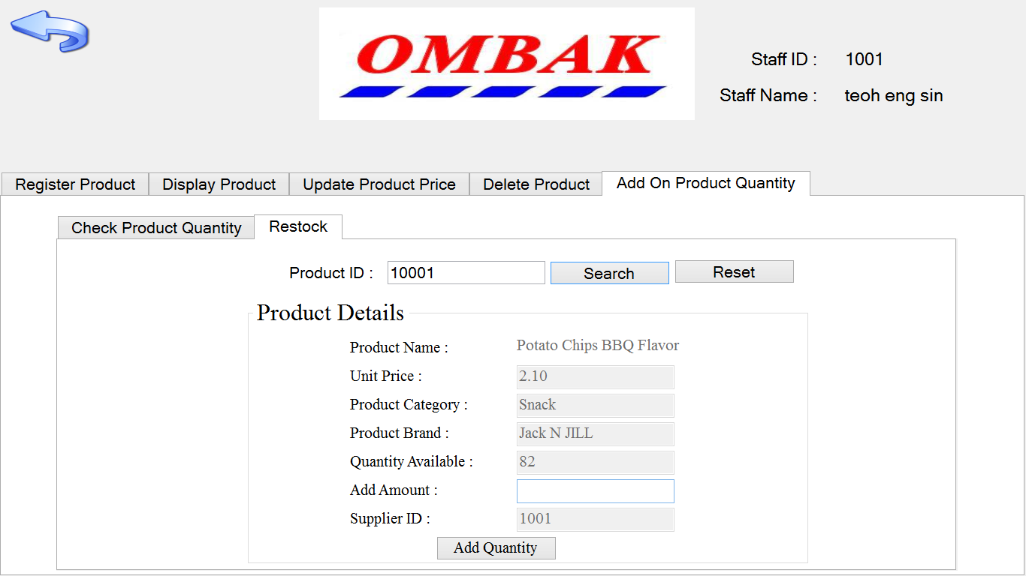

Figure 1: Show the interface of user story “allow staff to add on product quantity”

By default, the system only require the user enter the product id and then enter the quantity that need to be added. In this case, the customer feel that sometime the user cannot exactly know how many stock that wanted to be added. Therefore, the scrum master suggest that the product detail should include the quantity available for the specify product to let the user can directly know how many stock that need to be added. The customer agree with the suggestion from scrum master and finally the customer is also satisfied with the new field which is the quantity available field.